Jack Ma dethrones Wanda's Wang to take richest crown
By Yang Yang | chinadaily.com.cn | Updated: 2017-05-16 10:47
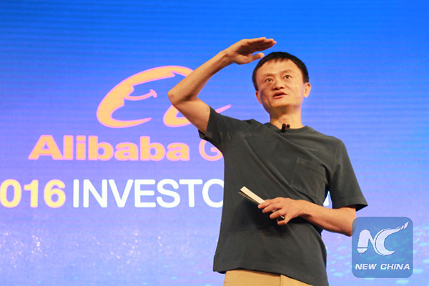
Alibaba's chairman Jack Ma delivers a speech at an investor conference at the company's headquarters in Hangzhou, East China's Zhejiang province, on June 14, 2016. The e-commerce giant Alibaba owns the online shopping platform Taobao. [Photo/Xinhua]
Jack Ma, chairman of China's e-commerce leader Alibaba Group, has surpassed Wang Jianlin, chairman of Dalian Wanda Group, to become the richest mainland Chinese, according to Forbes magazine.
As of Friday, Ma's fortune was worth $30.9 billion, compared with $30.7 billion for Wang. Ma Huateng, chairman of Tencent, took the third spot with $29.7 billion, according to the magazine.
Ma took the crown thanks to more than one-third rise in Alibaba's share price, which was $120.34 in New York on Friday.
Wang has made his wealth mainly from real estate and the entertainment industry.
In the past few years, Jack Ma and Wang Jianlin have rotated the No. 1 spot in China's wealth rankings.
However, the rankings may be poised for another shakeup as Ma Huateng's wealth increased rapidly following a run-up in the stock price of Tencent Holdings, which operates the country's popular WeChat online messaging platform. Ma Huateng's wealth is just $1 billion less compared with Ma and Wang.
Currently, Asia's richest man is Li Ka-shing of Hong Kong, with a fortune worth $32.9 billion, according to Forbes.
翻译：
阿里巴巴董事长马云在2016年6月14日在浙江省杭州市总部的投资者大会上发表演讲。电子商务巨头阿里巴巴拥有淘宝网上购物平台。
“福布斯”杂志说，中国电子商务领导阿里巴巴集团董事长马云已经超越了大连万达集团董事长王建林，成为中国最富有的国人。
截至周五，马的财富值309亿美元，而王先生的财富为307亿美元。 根据这份杂志，腾讯董事长马华腾以297亿美元收购了第三名。
马的财富摘取首富桂冠主要得感谢阿里巴巴的股价上涨了三分之一以上，周五纽约收市价为120.34美元。
王先生的财富主要来自房地产业和娱乐业。
过去几年，马云和王建林已经轮流坐庄中国财富排名。
不过，由于马华腾的财富在腾讯控股股价涨势后迅速上涨，因此腾讯控股公司运营该国流行的WeChat在线消息平台，排名可能还有待进一步调整。 马华腾的财富比马和王少了10亿美元。
目前，根据“福布斯”消息，亚洲首富李嘉诚，财富值329亿美元。

